# ***Challenge Name :- Lock Web***

**Description:-** "It's important to follow good content discovery methodology on sites you are testing. This is NOT always something like dirbuster or other bruteforcing approaches."

**Level:-** Easy

**Solution :-**

Step 1:- Open the url

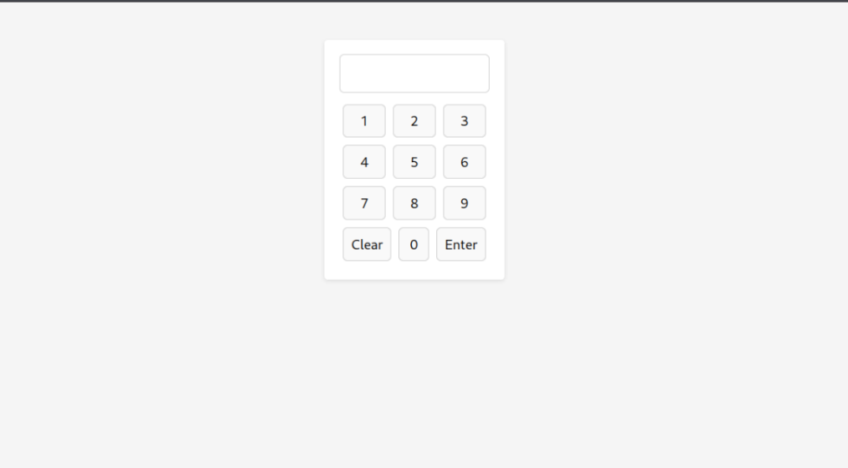

The basic disallowed subdomains are in the robots.txt .

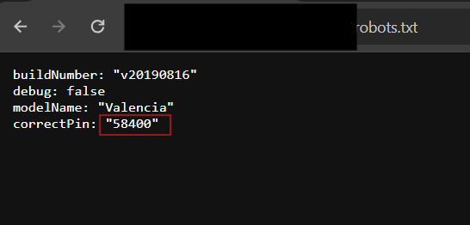

Decrypt it with using base36

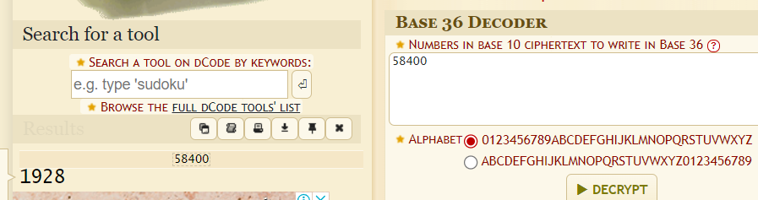

And Pin = 1928



This page is intentionally left blank